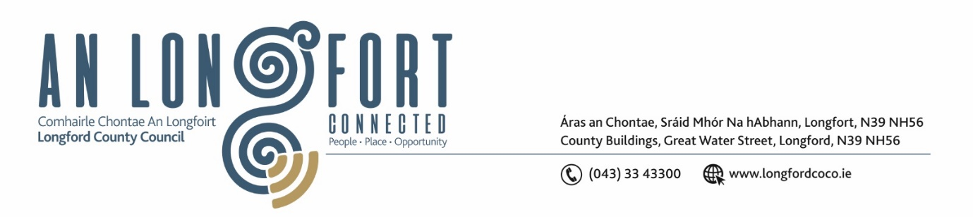

***Please note meeting will be held in the Council Chamber and via Microsoft Teams.***

3 Samhain 2022.

**Chuig: Gach Ball don Chomhairle.**

A Chomhairleoir,

Iarrtar ort bheith i láthair ag Cruinniú Míosuil Chomhairle Chontae Longfoirt a tionólfar i Seomra na Comhairle, Aras an Chontae, Longford agus via MS Teams are an **Chéadaoin 9ú Samhain 2022 ag** **4pm** chun gnó a dhéanamh d’réir an Chláir thíos.

You are requested to attend the Monthly Meeting of Longford County Council to be held in the Council Chamber and **via Microsoft Teams** on **Wednesday 9 November 2022 at 4pm** to transact business, as set out on the Agenda hereunder.

Mise le meas,

*Ann Marie Mc Keon*

**__________________**

**Ann Marie Mc Keon**

**Meetings Administrator.**

**C L Á R**

Prayer before meeting.

**1.** Confirmation of Minutes of Monthly Meeting of Longford County Council held on 12 October 2022– copy enclosed.

**2.** Matters Arising.

**3.** Declaration of Interest by Members.

**4.** To note Management Report – to follow.

**5.** To note adopted Minutes of Corporate Policy Group Meeting held on the

13 September 2022 – enclosed.

**6. Finance and IT**

1. To note adopted Minutes of meeting of Governance Strategic Policy Committee held on the 19 July 2022 – enclosed.
2. Consideration of disposal of property at 17 Oakvale, Longford, County Longford in accordance with the terms of Section 183 of the Local Government Act 2001 issued on the 5 October 2022 – as circulated.
3. Consideration of disposal of property at 25 Oakvale, Longford, County Longford in accordance with the terms of Section 183 of the Local Government Act 2001 issued on the 6 October 2022 – as circulated.
4. Consideration of disposal of property at 22 Congress Terrace, Longford, County Longford in accordance with the terms of Section 183 of the Local Government Act 2001 issued on the 25 October 2022 – as circulated.

**7. Community, Corporate and Enterprise**

**(a)** To note adopted Minutes of meeting of Placemaking Strategic Policy Committee held on the 18 July 2022 - enclosed.

**8. Planning and Project Delivery**

**(a)** To note Planning Applications received since last meeting of the Council.

**(b)** To note adopted Minutes of meeting of Climate Action and Planning Strategic Policy

Committee held on the 20 July 2022 - enclosed.

**(c)** Notice of Motions, submitted by Councillors, as listed hereunder –

**Councillor Gerry Warnock**

1. I’m calling on Longford County Council to write to the Minister for Housing to exempt Zoned Residential Lands in Longford for the incoming Residential Zoned Tax due to be implemented in 2024. The reason being is the dysfunctional nature of Longford’s housing market.
2. I am calling on the Members of Longford County Council to agree to formally write to the Minister and Secretary General of the Department of Housing & Local Government to inform them that we will not be approving any future Part 8 Planning Application for Social Housing Developments within County Longford until a scheme allowing for Affordable Housing Schemes to be developed in County Longford is officially ratified and approved by the Minister and the Department of Housing & Local Government.

**Councillor Uruemu Adejinmi**

**(i)** I am calling on the Department of Housing to allocate Resources to Longford County Council to enable the Planning department prepare and publish the maps identifying land within the scope of the Residential Land Zones Tax to meet the tight deadlines imposed by the Department.

1. I am calling on the Department of Housing to approve Affordable Housing Schemes for County Longford to incentivise build on land zoned as being suitable for residential development.

**9. Infrastructure, Housing and Innovation**

**(a)** To note adopted Minutes of meeting of Strategic Infrastructure Strategic Policy Committee held on the 21 July 2022 – enclosed.

**10. General**

**(a)** Notice of Motions, submitted by Councillors, as listed hereunder –

**Councillor Pauric Brady**

I call on Longford County Council to write to the Department of Agriculture, Food and the Marine looking for the closing date for the new Agri Climate Rural Environment Scheme (ACRES) to be extended as it didn’t give enough time for farmers to engage planners to survey their farms and devise meaningful farm sustainability plans, as required in the application.

**11.**  **Training – enclosed.**

**12. Votes of Sympathy**